CSA1708-ARTIFICIAL INTELLIGENCE
LAB EXPERIMENTS
Program 20 : Prolog Program for Planets Database
Aim
To create a Prolog database of the eight planets and query each planet's position and type.
Algorithm
1. Store each planet's name, order from the Sun, and type as a fact.
2. Define a rule that retrieves those details from the database.
3. Query the rule using a planet name.
4. Read the position and type returned by Prolog.
Program
planet(mercury, 1, terrestrial).
planet(venus, 2, terrestrial).
planet(earth, 3, terrestrial).
planet(mars, 4, terrestrial).
planet(jupiter, 5, gas_giant).
planet(saturn, 6, gas_giant).
planet(uranus, 7, ice_giant).
planet(neptune, 8, ice_giant).
planet_info(Name, Position, Type) :-
planet(Name, Position, Type).
Sample Input
?- planet_info(neptune, Position, Type).
Program Execution
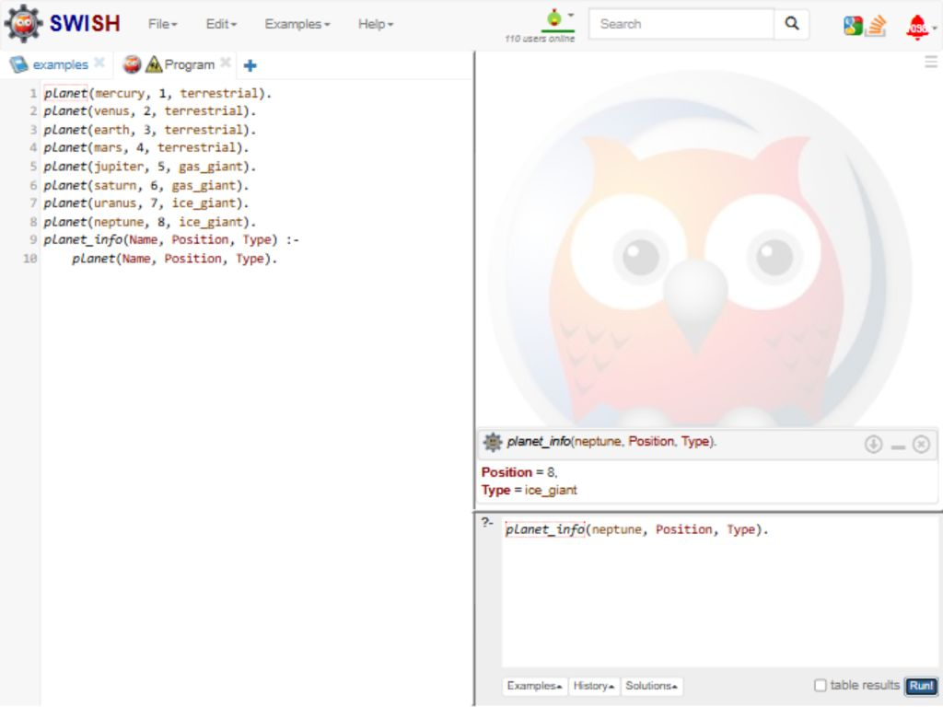
RESULT
Thus, the Prolog database returned position 8 and type ice_giant for Neptune.

